Iowa Hills Smith Chart

Note: Please notify us if you find a problem with this program. Email: Engineering@IowaHills.com

This is a quick example of how to use this program.

1. Go to the Set Load | Load Source Parasitics menu and enter 12 + j36 for the load impedance.
2. Go to the Shunt menu and choose Capacitor. A trace is drawn on the Smith Chart with alternating colors. Move the mouse about the trace and notice the cap value changing on the schematic. Click the mouse on the trace where the cap value is 5.6 pF.
3. Now place a series inductor. Click the mouse on the trace where the inductor is equal to 9.1 nH.
4. You have just matched a device with an input impedance of 12 + j36 to 50 ohms.
5. Click on a part value beneath the symbol. Use the arrow keys or F1 F2 to change the part value. The values change to the next standard value.

A few things to remember.
- Set the frequency before starting.
- The default reference impedance for the Smith Chart is 50 ohms, but you can set it to any convenient positive real value.
- Hot Keys.
Arrow and F1 and F2 keys are used to select and change component values.
D will delete the last part.
Right Click will also delete the last part.
Z or Y will toggle between Impedance and Admittance value display.
F5 to show the stability circles for an S parameter file.

A short lesson on matching.
If you are not familiar with Smith Charts, there is a simple lesson to be gleaned from the example given above. Notice the two circles that meet at the center of the chart. When starting to do a match, the goal is to work toward either one of these two circles. In the example, the shunt capacitor value was chosen so that it would move the impedance to the red circle that goes to the center of the chart. Then the series inductor could be used to get to 50 ohms. There are four ways to match 12 + j36 to 50 ohms at 1 GHz:
Shunt 5.6 pF cap and series 9.1 nH inductor.
Shunt 2.4 pF cap and a series 2.7 pF cap
Series 2.7 pF cap and shunt 4.7 nH inductor.
Series 11 pF cap and shunt 5.6 pF cap.
Transmission lines, transformers, and resistors could also be used.

Setting the Source impedance.
The default source impedance is 50 Ohms. This can be changed under the Set Load | Load Source Parasitics menu. The source impedance is plotted as a blue dot while the load is plotted as a red circle. If the source is complex, the default is to plot its complex conjugate. A complex source impedance may cause confusion. When designing a match between a complex load and a complex source, work from the load to the source’s conjugate value.

Why do we display the source’s conjugate, but not the load’s conjugate?

The answer to this is simply a matter of which direction we are look into the circuit. Here we did a match to 75 - j100. We then reversed the circuit to show that we end up at load's conjugate value.

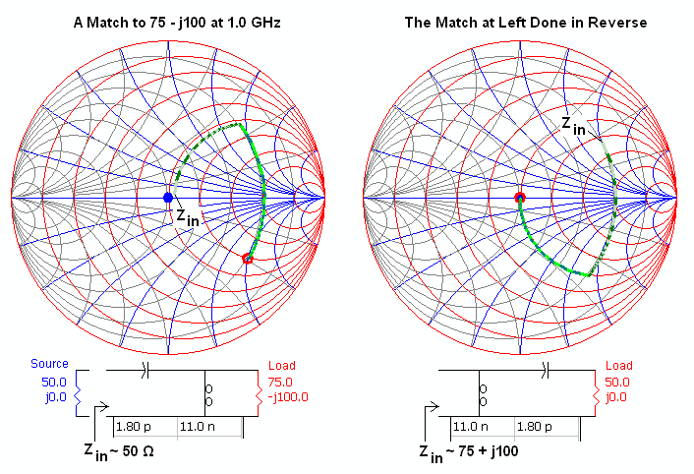

Setting the Load Impedance
The Load Impedance can be set with a Mouse Click, or by setting Rho or R+jX in the Set Load | Load Source menu, or by specifying an S parameter file.

S Parameters
The program allows you to match to either S11 or S22 directly, as defined in the spar file, or to match to the device's optimum impedance, which is calculated using the bilateral matching techniques discussed in High Frequency Amplifiers, Carson, Wiley and Sons, 1982.

The optimum input and output matching impedance will be the same as the conjugate of S11 and S22 if S12 = 0, otherwise they are different. The reason for this is that a nonzero S12 is supplying feedback between the device's input and output. Consequently, the impedance seen by the device at it's input affects it's output impedance, and vice versa.

This requires us to calculate the input and output match simultaneously, but this can only be done if the stability factor k is greater than 1. It is interesting to notice the amount of difference between an optimal matching impedance and S11 or S22. For large k, there is little difference between the two, but if k is near 1.0, the difference between them can be quite large.

Here is an example of the Smith Chart plotting control panel. On the left (F0 = 1.0 GHz) the "Opt Match" box is enabled because the stability factor k is greater than one. On the right (F0 = 7.0 GHz), the stability factor is less than one, so box is disabled.

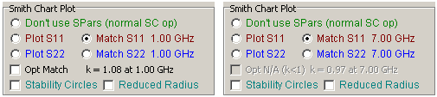

Use the panel shown here to control the frequency range of the data to be plotted on the Smith Chart. If the F0 / Span button is checked, only the data for that range of frequencies will be plotted. Check the "All Freqs in File" button to plot all the file data (this controls the frequency range for S11 and S22 plotting on the Smith Chart only).

If F0/Span is checked, the number of stability circles plotted is also controlled here. If S11 is selected, the input stability circles are plotted. If S22 is selected, the output stability circles are plotted. If the All Freqs button is checked, a stability circle for each frequency in the file will be plotted.

The impedance presented to the s parameter device is plotted as a black trace. It will fall in an area of the chart that is approximately the conjugate of the load. It is important that this black trace fall within the stable region in order to ensure stability. (The side of the stability circle that is stable is the side that includes the center of the Smith Chart, assuming that |S11| and |S22| < 1, which is usually the case.)

If you are new to stability circles, you need to understand that it is the impedance seen by the device that is of interest, and it is these impedances that must fall within the device's stable region at all frequencies, not just the design frequency. In other words, a 2 GHz amp that is presented an unstable match at 200 MHz will almost certainly oscillate at 200 MHz. Also keep in mind that the impedance of the source and load is unlikely to be 50 Ohms at all frequencies. It would be common for either the source or load or both to be a filter. Filters always present a high VSWR in the stop band and this will complicate the stability analysis a bit. This sort of analysis is far beyond the capabilities of this simple Smith Chart program.

1 Port SPar Files
The program will read in 1 port s parameter files. In this case, the program sets S22 and S12 to - 80 dB and sets S12 to 0 dB.

Q Circles and VSWR Circles
Q and VSWR circles can be placed on the chart from the Q and VSWR Circles menu. If you aren’t familiar with Q circles, here are a couple of points to notice. First, they are called Q circles because they trace out curves of constant reactance to resistance. Second, they trace out the same curve as a transformer. Third, they are useful when trying to maintain bandwidth in a matching circuit. In other words, a circuits bandwidth is determined by the value of the Q circle that it stays within.

For example, place 2 Q Circles on the chart, one at Q=5 and another at Q=1. Leave the load at 50 Ohms and place a Shunt L, Series C, and another Shunt L and work back to 50 Ohms. First select values where the traces on the chart extend to the Q=5 circles. Then modify the values so that the traces don't extend beyond the Q=1 circle and notice the bandwidth difference between the two circuits.

